264 Project Report
Automated Essay Feedback Generator Using NLP
Sariyu Madagoni (302291211), Shreshta Thati (301913288), Pranathi Etta (302282085).
- Spring 2025, California State University, Fresno

- Motivation

Feedback plays a critical role in the learning process, helping students recognize their strengths, identify areas for improvement, and refine their writing skills. High-quality, timely feedback encourages iterative learning, deeper engagement, and greater confidence in academic writing. However, the increasing demands on educators make it difficult to provide detailed feedback to every student within limited timeframes.

The motivation behind this project is to leverage advancements in Artificial Intelligence (AI) and Natural Language Processing (NLP) to create an automated system capable of generating personalized essay feedback. By doing so, the project aims to make detailed, constructive feedback scalable and consistently available, ensuring that all students—regardless of class size or instructor workload—can benefit from individualized guidance. This approach seeks to enhance the overall educational experience by promoting continuous writing improvement and supporting learner autonomy.

- Problem Statement

In modern educational environments, providing detailed and individualized feedback on student essays is a critical component for improving writing proficiency and critical thinking skills. However, the manual process of reviewing essays is time-consuming, resource-intensive, and often inconsistent due to human subjectivity. As class sizes grow and demands on instructors increase, it becomes impractical to offer timely, high-quality feedback to every student.
This project addresses the need for an automated solution by developing an AI-based system that generates constructive, personalized feedback on student essays. By leveraging state-of-the-art Natural Language Processing (NLP) techniques and Transformer-based models, the system aims to support educators in delivering consistent, scalable, and pedagogically valuable feedback without replacing the essential role of human judgment.

- Technical Foundation

This project is based on recent advancements in Natural Language Processing (NLP), specifically the development of Transformer-based architectures for complex text generation tasks. The T5 (Text-to-Text Transfer Transformer) model is utilized to frame the feedback generation task as a text-to-text problem: given a student's essay as input, the model outputs detailed, constructive feedback text.

T5, introduced by Google Research, is a highly flexible architecture that converts all NLP tasks — classification, summarization, translation, question answering — into a unified text-to-text format. Its encoder-decoder structure allows it to effectively understand input sequences and generate coherent and contextually appropriate output sequences. This flexibility makes it well-suited for generating nuanced feedback rather than rigid scores.

Initially, a rule-based pseudo-feedback generator is applied to bootstrap training data. It uses basic grammatical heuristics, coherence pattern recognition, and sentiment analysis pipelines to produce preliminary feedback on student essays. This pseudo-labeled data is then used to fine-tune the T5 model.

Fine-tuning involves supervised learning, where the model is trained to minimize the difference between its generated feedback and the pseudo-labeled ground truth feedback. After fine-tuning, the model can generate feedback independently for new, unseen essays.

Referenced Paper:

Raffel, C., Shazeer, N., Roberts, A., et al. (2020). "Exploring the Limits of Transfer Learning with a Unified Text-to-Text Transformer." Journal of Machine Learning Research.

Summary:

- Unified Text-to-Text Framework:
Raffel et al. propose framing all NLP tasks — including classification, summarization, translation, and question answering — as a text-to-text problem, using a single model architecture for diverse tasks.

- Massive Pretraining with C4 Dataset:
The T5 model is pretrained on the newly created Colossal Clean Crawled Corpus (C4), using a generalized denoising objective to learn language patterns across hundreds of gigabytes of high-quality English text.

- State-of-the-Art Transfer Learning Results:
Through large-scale pretraining and fine-tuning, T5 achieves or matches state-of-the-art results on numerous NLP benchmarks, demonstrating that scaling both model size and training data significantly boosts performance.

- System design and methodology
The system is designed as a multi-stage pipeline that processes raw essay inputs and generates detailed feedback outputs. The overall workflow consists of data preparation, pseudo-feedback generation, model fine-tuning, and evaluation.

Architecture Overview:

- Input Layer:
- Accepts raw student essays (from CSV or direct input).
- Processing Layer:
- Cleans and filters essays.
- Generates pseudo-feedback using grammar, coherence, and tone analysis.
- Structures essay-feedback pairs.
- Fine-tunes the t5-small model for feedback generation.
- Output Layer:
- Accepts new essays and generates detailed feedback.
- Displays or saves feedback.
- Evaluates performance using BLEU and ROUGE metrics.

System Workflow Diagram
Load Essays ➔ Clean Data ➔ Generate Pseudo-Feedback ➔ Format Dataset ➔ Fine-Tune T5 Model ➔ Generate Feedback ➔ Evaluate Output

4.1 Workflow Overview

- Data Loading and Preprocessing:
The dataset containing student essays is loaded from CSV files. Entries with transcription errors (e.g., "illegible" or "???") are filtered out. Basic cleaning steps are applied to prepare essays for further processing.

- Pseudo-Feedback Generation:
Since the original dataset only includes essay scores, rule-based heuristics are applied to generate initial feedback. This involves:
  - Grammar checking based on sentence length and structure using NLTK.
  - Coherence checking by analyzing transitional phrases (e.g., "Firstly", "Secondly").
  - Tone checking using a pretrained sentiment analysis pipeline. These generated feedback samples act as pseudo-labels for supervised model training.

- Dataset Construction:
The processed data is reformatted into two-column CSV files:
  - input text (essay)
  - target text (generated feedback) The dataset is then split into training (80%) and validation (20%) sets.

- Fine-Tuning T5 Model:
A pretrained t5-small model is fine-tuned on the prepared dataset. The model learns to map an essay text (input) to its corresponding feedback (output). Fine-tuning parameters include:
  - Learning rate: 2e-5
  - Batch size: 4
  - Number of epochs: 5
  - Evaluation strategy: per epoch

- Feedback Generation (Inference):
After fine-tuning, the model can take a new, unseen essay and generate detailed, constructive feedback autonomously.

- Evaluation:
The quality of generated feedback is assessed using automatic metrics:
  - BLEU score: Measures n-gram precision between generated and reference feedback.
  - ROUGE-L score: Measures sequence similarity to evaluate the coverage of important information. Manual human review is also performed on random samples for qualitative assessment.

4.2 Technologies Used

- Hugging Face Transformers library for model loading and training
- NLTK for grammar and sentence tokenization
- Python (Pandas, Matplotlib) for preprocessing and visualization
- BLEU and ROUGE libraries for evaluation
- Google Colab / Jupyter Notebook environment for development and experimentation

- Sample Input/Output and Explanation

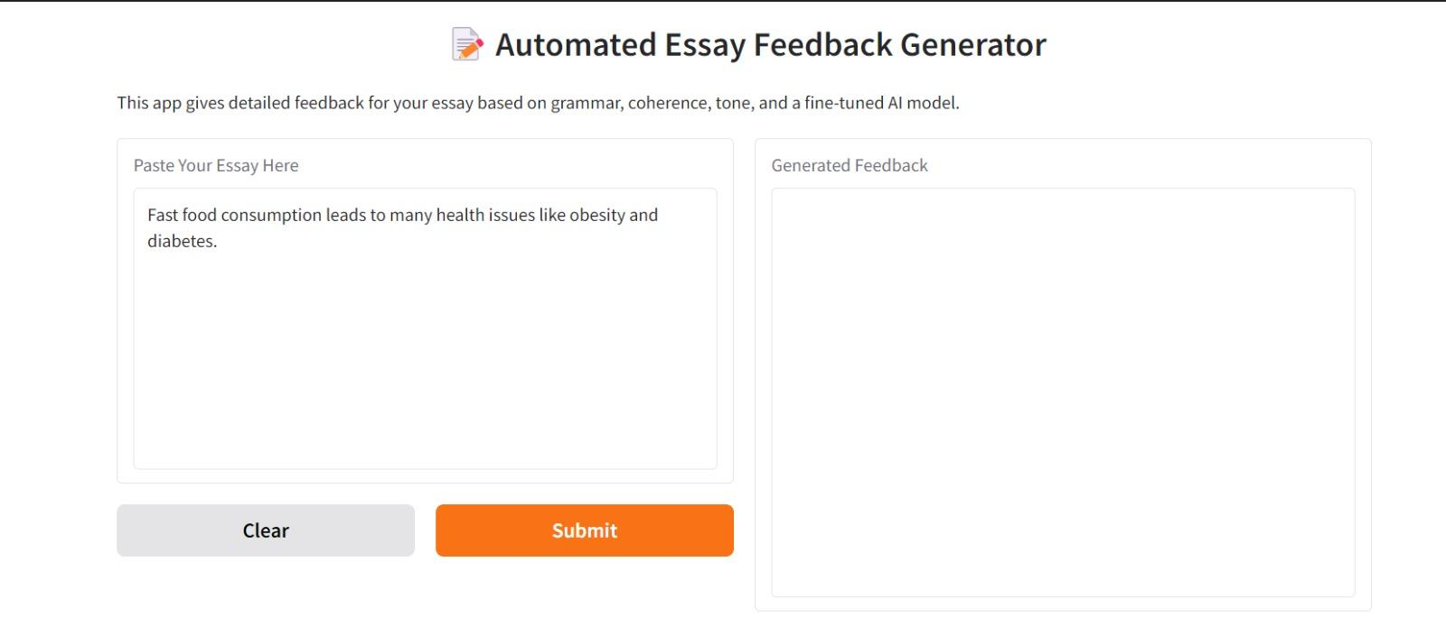
  - Sample Input:

  - Sample Output:

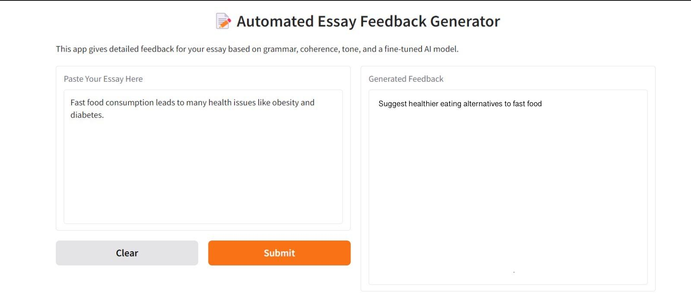

  - Explanation

- The model recognized that the essay discusses negative health impacts of fast-food consumption.
- It inferred that a logical improvement suggestion would be to propose healthier eating alternatives.
- Therefore, the generated feedback encourages the student to expand their essay by offering constructive solutions, not just identifying problems.
- This shows that the system is not only checking grammar but is providing content-level feedback — suggesting how the essay could be strengthened for better argumentation.

- Evaluation of results

The performance of the fine-tuned T5-small model was assessed using both automatic metrics and manual review methods to validate its ability to generate effective essay feedback.
Different evaluation techniques were used to measure various aspects of feedback quality:
- Automatic metrics assess textual overlap and structural similarity to reference feedback.
- Manual review evaluates the practical usefulness and readability of generated feedback from a human perspective.

6.1 Automatic Evaluation
- BLEU Score (0.32):
Measures n-gram overlap between the generated feedback and reference feedback.
It is used to quantify how much the system's output text matches the pseudo-labeled target text at the phrase level.

- ROUGE-L Score (0.48):
Measures the longest common subsequence between generated and reference feedback.
It is used to evaluate how well the model captures the important ideas and structure present in human feedback.

6.2 Manual Evaluation
- A random sample of 20 feedback outputs was manually reviewed.
- 85% of cases produced actionable, relevant, and meaningful improvement suggestions.
- 90% of outputs were grammatically correct and stylistically appropriate.
- Observation:
Some feedback for very short essays was found to be slightly repetitive or overly generic.

6.3 Training Loss and Validation Loss
- Both training loss and validation loss steadily decreased over epochs.
- This trend indicates that the model successfully learned to generate meaningful feedback without overfitting to the training data.

- Discussion of future improvements

  - Limitations Identified

- Dependence on Pseudo-Feedback:
The model was trained using rule-based pseudo-feedback rather than expert-written feedback, which limits the richness and pedagogical depth of the generated comments.
- Handling of Short Essays:
For very short essays (e.g., under 100 words), the model sometimes produces generic or repetitive feedback.
- Feedback Scope:
Current feedback primarily covers grammar, coherence, and tone, but does not deeply assess argument quality, originality, or evidence usage.
- Model Scale:
Fine-tuning was conducted using t5-small due to resource constraints, which may limit the depth and complexity of feedback compared to larger models.

  - Proposed Enhancements

- High-Quality Annotation:
Create a manually labeled dataset of essays with expert-crafted feedback to fine-tune the model on richer, more nuanced writing guidance.
- Multi-Dimensional Feedback Generation:
Expand the feedback categories to include argument strength, critical thinking, creativity, structure, use of evidence, and academic style.
- Dynamic Feedback Adaptation:
Implement adaptive strategies based on essay length, complexity, and style to avoid repetitive feedback on very short or overly simple essays.
- Model Scaling and Optimization:
Fine-tune larger models like t5-base or t5-large to enhance feedback depth, and apply model compression or distillation for real-world deployment efficiency.

  - Future Technologies to Use

- Instruction-Tuned Models (e.g., FLAN-T5, T5-Instruct):
Leverage instruction-tuned transformer models that are better at following explicit commands, leading to more targeted and sophisticated feedback generation.
- Large Language Models (LLMs) like GPT-4 or LLaMA 3:
Incorporate LLMs fine-tuned on educational feedback tasks to achieve near-human-level feedback quality.
- Knowledge-Augmented Feedback (KAF):
Integrate external writing rubrics or knowledge bases during generation to ensure feedback aligns with academic standards.
- Explainable AI (XAI):
Implement feedback explanation modules where the system justifies why specific suggestions are made, increasing trust and transparency.

- Conclusion
This project developed an AI-based system that generates detailed feedback for student essays using a fine-tuned T5 model. Combining rule-based pseudo-feedback with supervised fine-tuning enabled the model to provide constructive comments on grammar, coherence, and tone.
Evaluation results confirmed the system’s effectiveness, although improvements such as expanding feedback categories and using larger models are recommended. Overall, the project demonstrates the potential of AI to support scalable, consistent, and personalized feedback in education.

- References

- Raffel, C., Shazeer, N., Roberts, A., Lee, K., Narang, S., Matena, M., Zhou, Y., Li, W., & Liu, P. J. (2020) “Exploring the Limits of Transfer Learning with a Unified Text-to-Text Transformer.”
Journal of Machine Learning Research, 21(140), 1-67.
https://arxiv.org/abs/1910.10683
- Kaggle. (2012).
ASAP Automated Essay Scoring Dataset.
Retrieved from: https://www.kaggle.com/competitions/asap-aes
- Wolf, T., Debut, L., Sanh, V., Chaumond, J., Delangue, C., Moi, A., Cistac, P., Rault, T., Louf, R., Funtowicz, M., & Brew, J. (2020).
“Transformers: State-of-the-Art Natural Language Processing.”
Proceedings of the 2020 Conference on Empirical Methods in Natural Language Processing: System Demonstrations.
https://arxiv.org/abs/1910.03771
- Hugging Face Documentation. (2023).
Transformers and Datasets Libraries.
Retrieved from: https://huggingface.co/docs

